Timeless Smart Mall

Project

Business Plan

14/9/2024

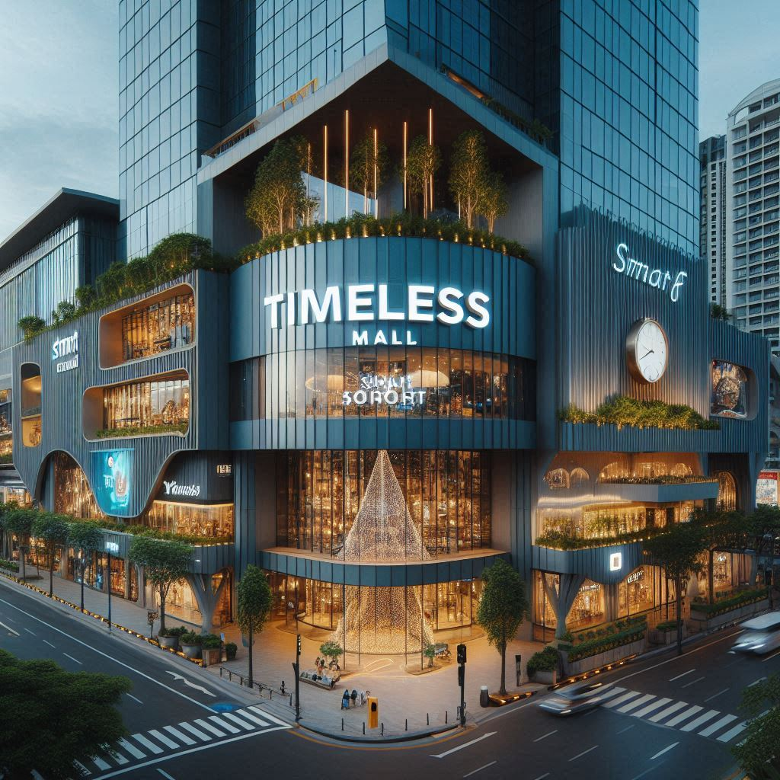

**TABLE OF CONTENTS**

1. TEAM MEMBERS 3
2. INTRODUCTION 4
3. BACKGROUND 5
4. PROJECT CHARTER 6
5. RESOURCES ALLOCATION PLAN 9
6. MARKETING PLAN 10
7. COMMUNICATION PLAN 11
8. RISK IDENTIFICATION 12
9. RISK ANALYSIS 13
10. RISK RESPONSE 14
11. QUALITY ASSURANCE PLAN 15
12. CONCLUSION 17

# TEAM MEMBERS

|  |  |
| --- | --- |
| **Name** | **Email** |
| Mohamed Osama Mohamed | [Mohammad.osamaa25@gmail.com](mailto:Mohammad.osamaa25@gmail.com) |
| Omar Wafaey Ahmed | [omerwafaey@gmail.com](mailto:omerwafaey@gmail.com) |
| Ahmed Abdelazeem Abdelrahman | [ahmedabdelazeemmm@gmail.com](mailto:ahmedabdelazeemmm@gmail.com) |
| Sherif Ahmed Abdelsalam | [Sherif.elzahar@gmail.com](mailto:Sherif.elzahar@gmail.com) |
| Ibrahim Mohamed Sadiq | [Ibrahim.Sadiq@gmail.com](mailto:Ibrahim.Sadiq@gmail.com) |

# INTRODUCTION

Welcome to the Timeless Mall project, where we are pioneering the future of shopping with our state-of-the-art smart solutions. As technology continues to advance at an unprecedented pace, Timeless Mall stands at the forefront, integrating cutting-edge technology and IoT to revolutionize the shopping experience.

Our project is dedicated to delivering innovative technology solutions designed to enhance every aspect of shopping. From intelligent systems that streamline operations to IoT-driven features that offer seamless connectivity, we aim to make shopping more convenient, efficient, and enjoyable for everyone.

The name "Timeless Mall" symbolizes our commitment to timeless innovation and modern convenience. Our solutions are crafted to remain relevant and effective as technology evolves, ensuring that our clients and their customers always benefit from the latest advancements.

It’s important to note that while our focus is on providing exceptional technology solutions, we do not engage in structural aspects of the mall’s construction. Our expertise is centered on enhancing the shopping experience through advanced technology, leaving the physical construction of the mall to other experts.

Join us as we embark on this exciting journey, transforming the way people shop and interact with their surroundings through smart, connected technology.

# BACKGROUND

The Smart Mall concept revolutionizes traditional retail environments by integrating advanced technologies to enhance shopping experiences and operational efficiency. This approach uses digital and automated systems to create a dynamic and interconnected environment.

**Key Technologies:**

* **Interactive Displays:** Offer real-time information and personalized content.
* **Self-Service Kiosks:** Facilitate tasks like ordering and information retrieval.
* **IoT Sensors:** Monitor and manage mall operations with real-time data.
* **Smart Lighting and HVAC:** Optimize energy use based on occupancy and conditions.
* **AI and Data Analytics:** Provide insights for personalized marketing and operational improvements.
* **Enhanced Security Systems:** Ensure safety with advanced surveillance and response capabilities.

**Benefits:**

* **Enhanced Shopper Experience:** Engaging, efficient, and personalized interactions.
* **Operational Efficiency:** Streamlined management and cost savings through automation.
* **Sustainability:** Reduced energy consumption and environmental impact.
* **Improved Security:** Increased safety through advanced monitoring systems.
* **Data-Driven Insights:** Targeted strategies based on consumer behavior analysis.

Integrating these technologies into Timeless Mall will set a new benchmark for modern retail spaces, delivering a sophisticated and responsive shopping experience.

# PROJECT CHARTER

|  |  |
| --- | --- |
| **Project Name** | **Project Supervisor** |
| Timeless Mall | Mohamed Osama |
| **Project Manager** | **Duration** |
| Sherif Elzahar | 1/1/2025 to 8/1/2027 |

|  |  |
| --- | --- |
| **Purpose** | * The purpose of this project is to transform an Egyptian local brand mall into a smart mall, enhancing its technological integration and operational efficiency to offer a cutting-edge shopping experience. |

|  |  |
| --- | --- |
| **Mission**  **And**  **Objectives** | * Implement technologies to improve shopping convenience and personalization, such as mobile apps for navigation, digital kiosks for information, and personalized promotions. * Introduce interactive elements like digital signage, smart parking solutions, and IoT-based services to engage customers and provide real-time information. * Deploy analytics tools to gather and analyze data on customer behavior, foot traffic, and sales trends to inform strategic decisions and marketing efforts. |

|  |  |
| --- | --- |
| **Budget** | * Overall Estimated Cost Range: $2,150,000 - $4,700,000 |

|  |  |
| --- | --- |
| **Scope in and out** | **In Scope:**   * Upgrading technology, enhancing customer experience, improving operational efficiency, and implementing advanced security systems.   **Out of Scope:**   * Major structural changes, unrelated facility upgrades, future tech integrations, and long-term maintenance.   Top of Form |

|  |  |
| --- | --- |
| **Risks** | * Potential delays due to technology integration issues and unforeseen costs related to system implementation and maintenance. |

|  |  |
| --- | --- |
| **Deliverables** | * **Smart Infrastructure Plan:** Detailed blueprint for technology and network upgrades, including sensor placement and integration points. * **Customer Experience Technologies:** Development and deployment of mobile apps, interactive kiosks, and digital directories to enhance user interaction and convenience. * **Operational Systems Integration:** Implementation of smart inventory management, energy-efficient systems, and automated facility maintenance solutions. * **Data Analytics Dashboard:** Creation of a comprehensive dashboard for real-time monitoring and analysis of customer behavior, foot traffic, and sales metrics. * **Security System Implementation:** Installation of advanced surveillance cameras, emergency alert systems, and smart access controls to enhance safety and security. * **Sustainability Solutions:** Integration of eco-friendly technologies such as smart lighting, energy-efficient HVAC systems, and waste management solutions. * **Training and Support Materials:** Development of training programs and user manuals to support mall staff and tenants in using the new technologies. * **Testing and Quality Assurance Report:** Documentation of thorough testing results for all implemented systems to ensure functionality and reliability. |

|  |  |
| --- | --- |
| **Timeline** | * Planning Phase: [1/1/2025 – 6/1/2025] * Implementation Phase: [6/1/2025 – 6/1/2027] * Testing and Calibration: [6/1/2027 – 7/1/2027] * Completion and Handover: [7/1/2027 – 8/1/2027] |

**OPERATING SCHEDULE**

|  |  |  |  |  |
| --- | --- | --- | --- | --- |
| **Task** | **Responsible** | **Duration** | **Start Date** | **End Date** |
| **Project Planning** | Sherif Elzahar  (Project Manager) | 2 months | 01/01/2025 | 02/28/2025 |
| **Technology Infrastructure Plan** | Ibrahim Sadiq  (IT Specialist) | 3 months | 03/01/2025 | 05/31/2025 |
| **Customer Experience Tech Development** | Mohamed Osama  (Senior Embedded Software Engineer) | 6 months | 06/01/2025 | 11/30/2025 |
| **Operational Systems Integration** | Omar Wafaey  (Operations Coordinator) | 4 months | 12/01/2025 | 03/31/2026 |
| **Data Analytics Dashboard** | Mohamed Osama  (Senior Data Analyst) | 3 months | 04/01/2026 | 06/30/2026 |
| **Security System Implementation** | Layla Nasser (Security Specialist) | 4 months | 07/01/2026 | 10/31/2026 |
| **Sustainability Solutions** | Layla Nasser (Sustainability Consultant) | 3 months | 11/01/2026 | 01/31/2027 |
| **Training and Support Materials** | Ahmed Abdelazeem  (HR & Training Manger) | 2 months | 02/01/2027 | 03/31/2027 |
| **Testing and Quality Assurance** | Omar Wafaey  (Senior Testing Engineer) | 3 months | 04/01/2027 | 06/30/2027 |
| **Customer Communication Strategy** | Ahmed Abdelazeem  (Marketing Specialist) | 2 months | 07/01/2027 | 08/31/2027 |
| **Post-Implementation Review** | Sherif Elzahar  (Project Manager) | 1 month | 09/01/2027 | 09/30/2027 |

|  |  |  |  |  |  |
| --- | --- | --- | --- | --- | --- |
| **Resources** | **Role** | **Team** | **Efforts (Months)** | **Rate/Month** | **Total Cost (USD)** |
| Sherif Elzahaar | Project Manager | Management | 24 | 12,000 | 288,000 |
| Ibrahim Sadiq | IT Specialist | IT & Operations | 18 | 11,000 | 198,000 |
| Mohamed Osama | Development Lead / Data Analyst | Development & Data Analysis | 15 | 10,500 | 157,500 |
| Omar Wafaey | Operations Coordinator / QA Lead | Operations & QA | 12 | 9,500 | 114,000 |
| Layla Nasser | Security Specialist / Sustainability Consultant | Security & Sustainability | 10 | 10,000 | 100,000 |
| Ahmed Abdelazeem | HR / Marketing Specialist | HR & Marketing | 8 | 8,500 | 68,000 |
| **Subtotal for Employees** |  |  |  |  | **925,500** |
| Smart Sensors | Materials | Procurement | N/A | N/A | 400,000 |
| Digital Kiosks | Materials | Procurement | N/A | N/A | 300,000 |
| Security Cameras | Materials | Procurement | N/A | N/A | 200,000 |
| HVAC Systems | Materials | Procurement | N/A | N/A | 250,000 |
| Advanced Lighting | Materials | Procurement | N/A | N/A | 200,000 |
| Interactive Digital Displays | Materials | Procurement | N/A | N/A | 250,000 |
| **Subtotal for Materials** |  |  |  |  | **1,600,000** |
| **Total Cost** |  |  |  |  | **2,525,500** |

# RESOURCES ALLOCATION PLAN

# MARKETING PLAN

**Target Audience**

1. Tech-Savvy Shoppers:
   * Description: Early adopters of technology seeking interactive and digital experiences.
   * Demographics: Ages 18-45, professionals, and students.
2. Families:
   * Description: Households looking for family-friendly, convenient shopping environments.
   * Demographics: Parents aged 25-50 with children.
3. Retailers and Businesses:
   * Description: Retailers needing a modern platform for enhanced customer engagement.
   * Demographics: Business owners and managers.
4. Tourists and Visitors:
   * Description: Individuals exploring modern shopping experiences.
   * Demographics: Domestic and international tourists, ages 18-60.

**Marketing Strategies**

1. Digital Marketing:
   * Social media: Targeted ads on Facebook, Instagram, and Twitter.
   * Influencers: Collaborations for buzz and reviews.
   * Email Campaigns: Personalized newsletters showcasing smart features.
2. Content Marketing:
   * Website: Interactive site detailing smart features and events.
   * Blogging: Articles on innovations and shopping tips to boost engagement and SEO.
3. In-Mall Promotions:
   * Launch Event: Live demos, exclusive offers, and entertainment.
   * Interactive Displays: In-mall screens promoting events and sales.
4. Local Partnerships:
   * Business Collaborations: Joint promotions with local businesses.
   * Community Engagement: Sponsorships and involvement in local events.
5. Public Relations:
   * Press Releases: Announcements of technological advancements and milestones.
   * Media Tours: Exclusive tours for journalists and bloggers.
6. Customer Engagement:
   * Loyalty Programs: Rewards for frequent visitors.
   * Feedback Channels: Collect and act on customer feedback.

# COMMUNICATION PLAN



# RISK IDENTIFICATION

|  |  |  |
| --- | --- | --- |
| **Risk** | **Type** | **Description** |
| Technology Compatibility Issues | Technical | Challenges with integrating new smart technologies with existing systems. |
| Data Security and Privacy Concerns | Compliance/Technical | Risks associated with protecting user data and ensuring privacy in digital systems. |
| Unforeseen Technical Challenges | Technical | Unexpected technical problems that may arise during implementation and deployment |
| Dependency on External Suppliers | Operational | Risks related to reliance on third-party vendors for critical components or services. |
| Budget Overruns | Financial | Risks of exceeding the allocated budget due to unforeseen costs or scope changes |
| User Adoption and Training | Organizational/Operational | Issues with getting staff and users to effectively adopt and utilize new technologies. |
| Regulatory Compliance | Compliance | Challenges in meeting legal and regulatory requirements for smart technologies. |
| Environmental Factors | External | Risks related to environmental conditions that could impact project implementation or operation. |
| Supply Chain Disruptions | Operational | Risks of delays or issues in the supply chain affecting the availability of materials or components. |

# RISK ANALYSIS

|  |  |  |  |
| --- | --- | --- | --- |
| **Risk Type** | **Probability** | **Impact** | **Severity** |
| **Technology Compatibility Issues** | High | Moderate | High |
| **Data Security and Privacy Concerns** | Medium | High | High |
| **Unforeseen Technical Challenges** | Medium | High | High |
| **Dependency on External Suppliers** | High | Moderate | High |
| **Budget Overruns** | Medium | High | High |
| **User Adoption and Training** | Medium | High | High |
| **Regulatory Compliance** | High | High | High |
| **Environmental Factors** | Low | Moderate | Low |
| **Supply Chain Disruptions** | High | Moderate | High |

# RISK RESPONSE

|  |  |
| --- | --- |
| **Risk** | **Response Plan** |
| Technology Compatibility Issues | Conduct thorough pre-implementation testing and validation. Engage with technology vendors early to ensure compatibility. |
| Data Security and Privacy Concerns | Implement robust data protection measures and encryption. Regularly update and audit security protocols. Provide clear privacy policies. |
| Unforeseen Technical Challenges | Establish a dedicated technical support team. Create a contingency plan with flexible timelines and resources to address unexpected issues. |
| Dependency on External Suppliers | Develop relationships with multiple suppliers. Include contingency plans and alternative suppliers to mitigate risks of delays. |
| Budget Overruns | Monitor budget closely with regular financial reviews. Implement strict change control processes and prepare a contingency budget. |
| User Adoption and Training | Develop a comprehensive training program. Offer ongoing support and resources to facilitate smooth adoption and address user concerns. |
| Regulatory Compliance | Stay updated with relevant regulations and standards. Engage legal and compliance experts to ensure all aspects of the project meet legal requirements. |
| Environmental Factors | Assess environmental impacts early and incorporate sustainability practices. Prepare for potential environmental disruptions with contingency plans. |
| Supply Chain Disruptions | Diversify suppliers and maintain safety stock of critical materials. Monitor supply chain conditions and establish quick response procedures for disruptions. |

# QUALITY ASSURANCE PLAN

|  |  |  |  |  |
| --- | --- | --- | --- | --- |
| **Aspect** | **Question** | **Yes / No** | **Functionality** | **Comments** |
| **Functionality** | Do all systems work correctly as designed? | Yes | Systems are operating efficiently as expected | All features are functioning correctly. |
| **Security** | Are the systems secure and providing the required protection? | Yes | Systems include robust security measures | Encryption and access controls are fully implemented. |
| **User Interface** | Is the user interface easy to use and smooth? | Yes | Interface is user-friendly and enhances customer satisfaction | Comfortable and easy for user interaction. |
| **Compatibility** | Are the systems compatible with other devices and applications? | Yes | Systems integrate with multiple devices | Integration with all required devices is achieved. |
| **Data Handling** | Is data handled efficiently and with privacy? | Yes | Data is managed efficiently and confidentially | Compliance with all privacy standards. |
| **Performance** | Do the systems perform acceptably without delays? | Yes | Systems operate swiftly and efficiently | No noticeable performance delays. |
| **Integration** | Do different systems integrate seamlessly? | Yes | Smooth integration between all systems | Systems work harmoniously without conflicts. |
| **Error Handling** | Does the system handle error and issues effectively? | Yes | Effective and prompt error handling | System addresses and resolves errors efficiently. |
| **Maintenance** | Is the system easy to maintain and update? | Yes | Maintenance and updates are straightforward | Updates are easily applied and maintenance is effective. |
| **Usability** | Is the system easy for average users to operate? | Yes | System is easy to learn and use | Provides an excellent user experience with comprehensive support. |

# CONCLUSION

In conclusion the initiative to integrate smart solutions into the upcoming Timeless Mall marks a transformative step towards modernizing the retail experience and enhancing operational efficiency. This project aims to seamlessly incorporate advanced technologies into the new mall, creating an environment that is not only innovative but also responsive to the needs of both customers and retailers.

By embedding smart solutions such as interactive digital displays, self-service kiosks, and IoT-driven infrastructure, the project is set to redefine the traditional mall experience. These technologies will offer enhanced convenience, personalized shopping experiences, and efficient mall management, setting a new benchmark for future retail environments.

The successful implementation of these smart solutions will position Timeless Mall as a cutting-edge destination that attracts and engages shoppers through its advanced technological features. As we proceed, collaboration and effective execution will be key to realizing the vision of a truly smart mall, ensuring that Timeless Mall becomes a model of innovation and efficiency in the retail sector.